Supplementary information for Part 2

The following time-series chart shows the contributions of each month to the increased Australian summer warming rate of 57% as described HERE.
Importantly all of the time-series plots reviewed typically have increased warming in recent years when there are no grounds for homogenization.

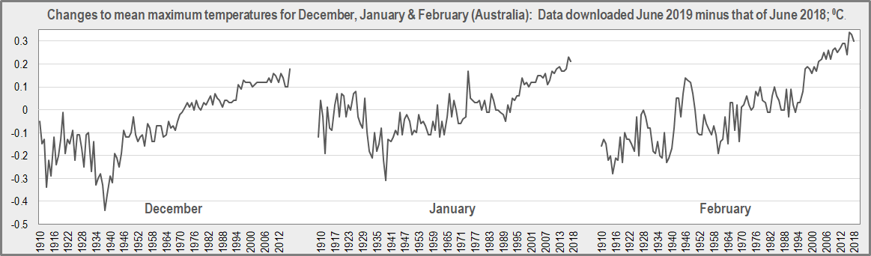

The upward adjustments in the final three years for each time-series follow:

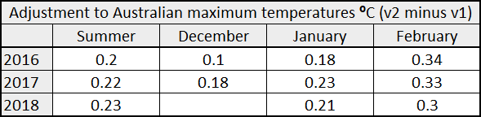

None of the 104 individual ACORN-SAT stations used for the national time-series show any changes in the final three years. This can be quickly seen by visiting Chris Gillham’s excellent ‘Scribeworks’ website. Here for example is a chart for the iconic Alice Springs in Northern Territory, located at almost the centre of Australia (The chart also includes the historical ‘raw’ data, green):

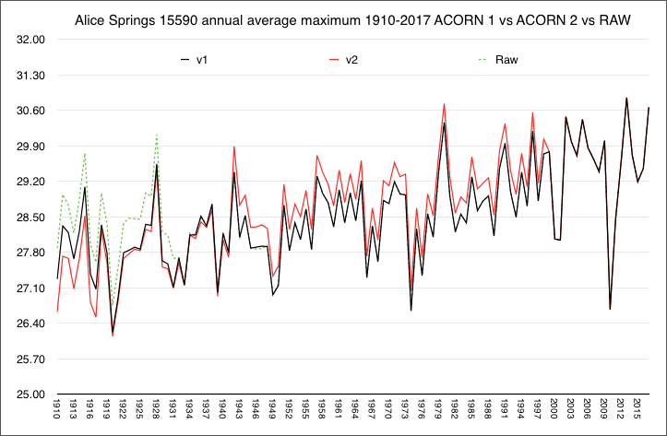

This shows that v1, v2 (and raw) data merge as a common line from about 1997 through 2017 (their differences = 0).

Up until 1957, Alice Springs famously had the greatest share in area-weighting of the national average because of its remoteness. In 1957 Giles in remote eastern Western Australia was opened and became the dominant area-weighted station. It reveals some interesting details:

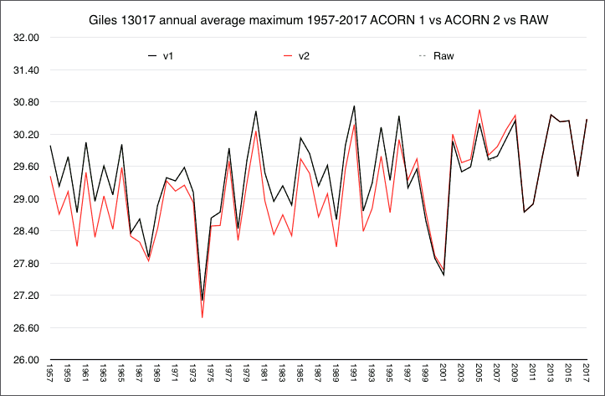

As with Alice springs, “Raw” and v1 are identical for unusually long timespans; entirely for Giles. V2 and v1 are identical from about 2010 through 2017. The years 1957 through 1964 are cooled in v2 by about 0.7 ⁰C.

Next follows a more elaborative combination chart for South Australia. This State was selected for simplicity because it only has twelve ACORN-SAT stations to analyse.
The left-hand section is blank when v2 minus v1 is zero, and the black bars indicate when there is actually a difference. Dates in bold indicate when the difference does actually occur if it is off-chart.
The right-hand section shows the Dec/Jan/Feb v2 minus v1 differences for the area-weighted State averages for the period 1997 through 2018 (the start date of 1997 is a matter of separate later interest).

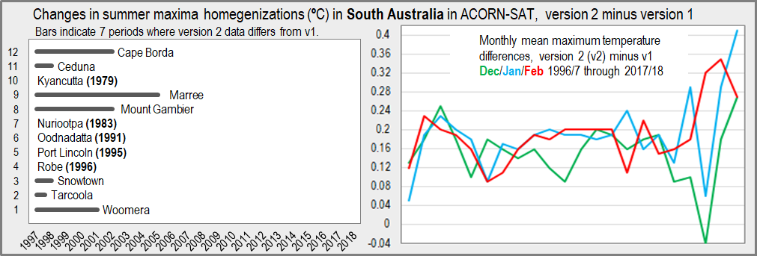

The 12 individual stations in the left-hand frame, all with zero values, become positive when area-weighted and averaged on the right-hand side. Some rather wild swings in the modelled data are seen in the final three years. Giles and Birdsville in Queensland may have some area-weighting contributions in the right-hand chart but they also have no differences between v2 and v1 individually.

Bob Fernley-Jones 4 November 2019

